**Azure fundamental assignment 3**

1. What is Azure App Service and when to opt for Azure App Service?

Azure App Service is an HTTP-based service for hosting web applications, REST APIs, and mobile backends. You can develop in your favourite language such as .NET, .NET Core, Java, Ruby, Node.js, PHP, Python. Applications can be easily run and scaled in both Windows-based and Linux-based environments.

App Service is a Platform as a Service (PaaS) provided by Microsoft. Use it to host web applications, REST APIs, and back-end services for mobile applications.

It doesn't matter what programming language or framework you use. Web applications and services developed using either of the following programming languages ​​or frameworks can be hosted on Azure App Service.

* .NET\.NET Core
* Java
* Ruby
* Node.js
* PHP
* Python

Azure App Service is a fully managed platform as a service (PaaS) offering for developers. Here are some key features of App Service:

* Multiple languages and frameworks
* Managed production environment
* Containerization and Docker
* DevOps optimization
* Global scale with high availability
* Connections to SaaS platforms and on-premises data
* Security and compliance
* Application templates
* Visual Studio and Visual Studio Code integration
* API and mobile features
* Serverless code

1. Differentiate Azure Container Instances and Azure Kubernetes Service

**Azure Container Instances**

Azure Container Instances (ACI) is a Microsoft Platform as a Service (PaaS) solution that provides the fastest and easiest way to run containers in Azure without having to manage the underlying infrastructure. Use Azure Kubernetes Service (AKS) for container orchestration in Azure (creating, managing, and deploying multiple containers). You can deploy an Azure container instance using the Azure portal, Azure CLI, Powershell, or ARM templates.

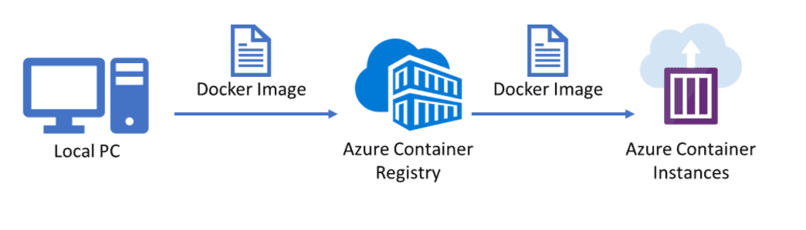

**Azure Kubernetes Service**

Azure Kubernetes Service (AKS) is a managed Kubernetes service where master nodes are managed by Azure and end-users manage worker nodes. Users can use AKS to deploy, scale, and manage Docker containers and container-based applications across a cluster of container hosts. As a managed Kubernetes service, AKS is free. You only pay for worker nodes in the cluster, not for masters.

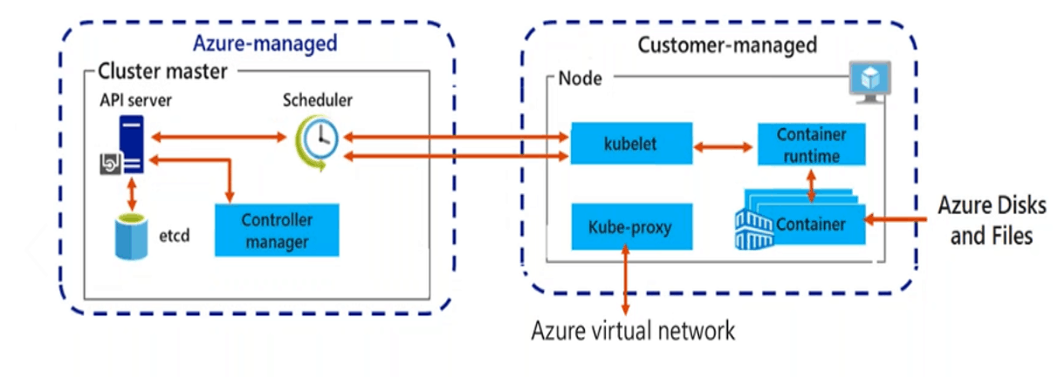

|  |  |  |
| --- | --- | --- |
|  | Azure Container Services | Azure Kubernetes Service |
| Description | Run containers without managing servers. | Orchestrate and manage multiple container images and applications. |
| Deployment | For event-driven applications, quickly deploy from your container development pipelines, run data processing, and build jobs. | Uses clusters and pods to scale and deploy applications. |
| Web Apps (Monolithic) | Yes | Yes |
| N-Tier Apps (Services) | Yes | Yes |
| Cloud-Native (Microservices) | Yes | Yes, recommended for Linux containers |
| Batch/Jobs (Background tasks) | Yes | Yes |
| Use cases | * Dev/Test scenarios * Task automation * CI/CD agents * Small/scale batch processing * Simple web apps | * Containers and application configuration portability * Enables you to select the number of hosts, size, and orchestrator tools * Transfer container workloads to the cloud without changing your current management practices. |
| Major Difference | You should use AKS if you need full container orchestration, such as service discovery across multiple containers, automatic scaling, and coordinated application upgrades. | |

1. What is the Azure function? Explain in brief.

Azure Functions is Microsoft's serverless computing service that can execute code in response to predefined events or conditions (triggers) such as: When an order arrives at the IoT system, or when a particular queue receives a new message. It automatically manages all the computing resources required by these processes.

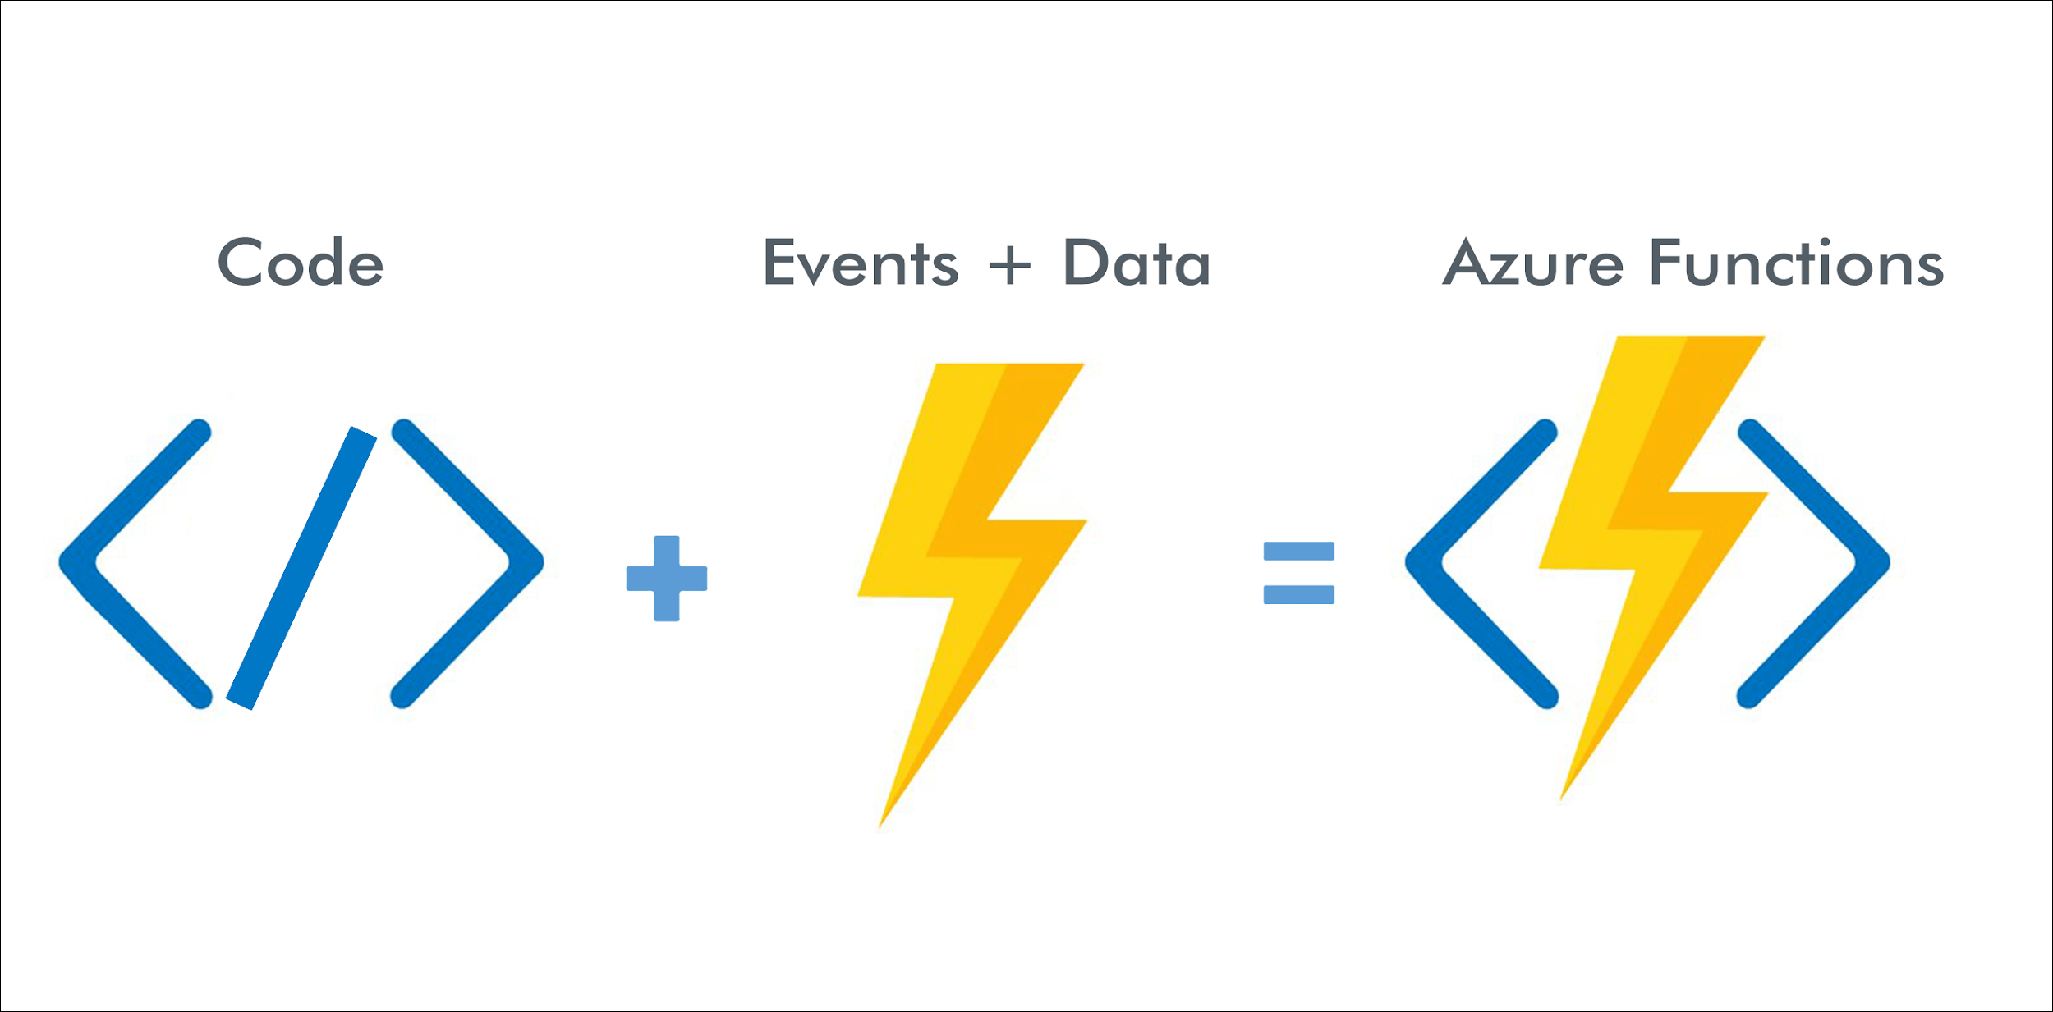

The serverless Azure Functions platform allows teams to build event-driven apps that execute code when triggered by preconfigured system conditions or events. The platform automatically manages all the computing resources needed for these processes, allowing DevOps teams to focus on developing and deploying features.

With Azure Functions, teams can also run custom code to connect multiple JavaScript, C #, Python, or PHP services on demand in a containerized environment.

Azure Functions offers Compute-On-Demand in two main ways.

* + First, Azure Functions allows you to implement your system's logic in out-of-the-box code blocks. These code blocks are called "functions". You can perform various functions at any time when you need to respond to important events.
  + Then, as demand grows, Azure Functions will use the required number of resources and function instances to meet the demand, but only if they are needed. When demand decreases, all additional resources and application instances are automatically deleted.

An Azure Function is a code triggered by an event whereas an Azure Logic app is a workflow triggered by an event.

* + Azure Functions can be triggered with the configured trigger like HTTP Trigger, Timer Trigger, Queue Trigger and more
  + Workflow in Azure Functions can be defined using Azure Durable Function. It consists of Orchestrator Function that has the workflow defined with Several Activity Functions
  + Azure Functions can be monitored using Application Insights and Azure Monitor

1. What is Azure Virtual Desktop?

Azure Virtual Desktop is a desktop and app virtualization service that runs on the cloud.

Microsoft Azure Virtual Desktop is a cloud-based virtual desktop and application platform that runs on Azure with exclusive features such as Windows 10 Enterprise Multisession. This offering allows multiple users to connect to a remote desktop on a Windows 10 virtual machine at the same time for optimal app compatibility and a familiar user experience without an RDS CAL license. Extended support is also available for Windows 7, so you can run legacy apps safely and efficiently in the cloud.

Benefits of a virtual desktop

* Your staff need to work remotely
* Simple security management
* You have an occasional need for PCs
* You need different types of PCs for different teams in the business

1. What is Azure virtual networking? Explain in detail.

An Azure Virtual Network (VNet) is a network or environment that can be used to run VMs and applications in the cloud. When it is created, the services and Virtual Machines within the Azure network interact securely with each other.

Benefits of using an Azure virtual network. Some of the main benefits of using Microsoft Azure VNet are:

* + Provides an isolated environment for applications
  + By default, VNet subnets can access the public internet
  + Easily direct resource traffic
  + It is a highly secure network
  + Has high network connectivity
  + Build a sophisticated network topology in an easy way
  + Next, let's take a look at the components of Azure VNet.

**Components of Azure VNet**

Azure network components provide a wide range of capabilities to help organizations build efficient cloud applications that meet their needs. The components of Azure Networking are listed below and each of these components is described in detail.

* Subnets
* Routing
* Network Security Groups

**Subnets**

* Subnets let users segment the virtual network into one or more sub-networks.
* These sub-networks can be separated logically, and each subnet consists of a server.
* We can further divide a subnet into two types:

1. Private - Instances can access the Internet with NAT (Network Address Translation) gateway that is present in the public subnet.
2. Public - Instances can directly access the internet.

**Routing**

* + It delivers the data by choosing a suitable path from source to destination.
  + For each subnet, the virtual network automatically routes traffic and creates a routing table.

**Network Security Groups**

* + It is a firewall that protects the virtual machine by limiting network traffic.
  + It restricts inbound and outbound network traffic depending upon the destination IP addresses, port, and protocol.

**Steps to Creating Azure Virtual Machine and Virtual Network**

* + Step 1 − First, log into your Azure Management Portal, select 'New' at the bottom left corner.
  + Step 2 − Next, on the Network Services go to Virtual Network -> Quick create.
  + Step 3 - Now, enter the name and leave all other fields empty and click 'next'.
  + Step 4 − Finally, click on 'Create a Virtual Network,' and it is done.
  + **Note:** Now, in the same VNet, create a Virtual machine
  + Step 5 - First, select ‘create’ to build a new Virtual Machine with Windows Server 2012 R2 Data center.
  + Step 6 - Once the fields are entered, select the existing resource group that you had created for the virtual network and select OK.
  + Step 7 - Now, choose a desired size and configuration by selecting DS1_V2 Standard type
  + **Note:** By default, we would choose a Virtual Network.
  + Step 8 - Now select the subnet as FrontEndSubnet and do not change the public IP address. Also, keep the Network Security Group as none.
  + Step 9 - Create a new availability set and set a new name to it.
  + Next, set the fault domains as 2 and then disable the Guest OS Diagnosis section.
  + Step 10 - Finally, click and select ‘create’.

***Congratulations, you have successfully created a VM.***

1. Explain the Azure VPN gateway.

Microsoft Azure offers the opportunity to work in a hybrid work environment where you can integrate your company's servers and physical devices into the cloud. To perform this task, our suggestions are based on the use of a virtual private network (Azure virtual private network or VPN) that acts as a gateway.

Azure VPN Gateway is a cloud-based network gateway that enables connecting on-premises networks with Azure using site-to-site VPNs. Azure VPN Gateway provides secure connectivity by using industry-standard protocols, IPsec and IKE to secure the connection. In order to build the connection, Azure requires using its preferred gateway devices vendors for establishing a site to site connection. It can also be used to establish a connection between virtual networks i.e. VNet to VNet. and it provides two different types of gateways;

**Static Routing –** Delivers policy based VPN connectivity and routing

**Dynamic Routing –** Provides route based VPN connectivity and routing

It enables organizations to;

* + Create a site to site VPN connection between on-premises IT Infrastructure or from any location with Azure-hosted resources
  + Create secure VPN connections with on premises and Azure
  + Connect on premises servers with virtual machines, SQL Azure or other Azure Cloud resources.

**Azure VPN Gateway**

The VPN Gateway service allows you to connect the virtual network to the local area network using a VPN device. This service includes the following elements:

* **Virtual network gateway:** The resource that provides a virtual VPN device for the virtual network. It is responsible for routing traffic from the local area network to the virtual network.
* **Local area network gateway:** Abstraction of the local VPN device. Network traffic from the application in the cloud to the local area network is routed through this gateway.
* **Connection:** The connection has properties that specify the type of connection (IPSec) and the shared key with the local VPN device to encrypt traffic.
* **Gateway subnet:** The virtual network gateway is maintained on its own subnet.